Bonus eftpos Gift Card Promotion 2020
Mitsubishi Electric is pleased to announce the launch of our 2020 Winter Gift Card Redemption Offer. This offer entitles our consumers who purchase any selected split or ducted unit the opportunity to redeem a bonus eftpos gift card.
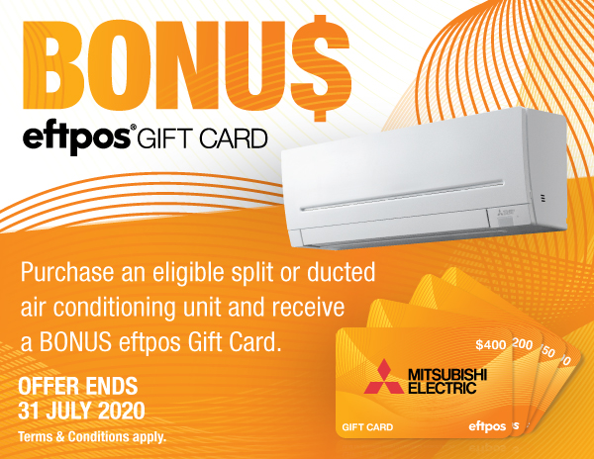
Mitsubishi Electric is pleased to announce the launch of our Winter eftpos Gift Card 2020 Redemption Offer.
This offer entitles our consumers who purchase any selected split or ducted unit the opportunity to redeem a bonus eftpos gift card.
Mitsubishi Electric air conditioners are world-class systems with industry leading technology. What does that mean for you and your home? Sleek, attractive air conditioning units with quieter operation and reliability.
To register for your bonus eftpos gift card and full Promotion Terms and Conditions go to https://mitsubishi.edgeclaims.com.au/.
- Promotion start: 01/04/2020
- Promotion end: 31/07/2020
- Claims must be submitted by 31/08/2020
- To process redemption go to: https://mitsubishi.edgeclaims.com.au/
- To activate a Gift Card go to: www.activatemycard.com.au/meaust
- To check your claim status go to: https://mitsubishi.edgeclaims.com.au/ClaimStatus
- Promotion helpline: 1300 431 011

Eligible models
Air Conditioner Model | Description | Bonus Gift Card Value
MSZ-LN25KIT | 2.5 kW deluxe wall mounted split system | $100
MSZ-LN35KIT | 3.5 kW deluxe wall mounted split system | $100
MSZ-LN50KIT | 5.0 kW deluxe wall mounted split system | $100
MSZ-LN60KIT | 6.0 kW deluxe wall mounted split system | $100
MSZ-EF25VE2B/W/SKIT | 2.5 kW flat panel wall mounted system | $100
MSZ-EF35VE2B/W/SKIT | 3.5 kW flat panel wall mounted system | $100
MSZ-EF42VE2B/W/SKIT | 4.2 kW flat panel wall mounted system | $100
MSZ-EF50VE2B/W/SKIT | 5.0 kW flat panel wall mounted system | $100
MSZ-AP25VG(D*)KIT | 2.5 kW wall mounted split system | $100
MSZ-AP35VG(D*)KIT | 3.5 kW wall mounted split system | $100
MSZ-AP42VG(D*)KIT | 4.2 kW wall mounted split system | $100
MSZ-AP50VG(D*)KIT | 5.0 kW wall mounted split system | $100
MSZ-AP60VG(D*)KIT | 6.0 kW wall mounted split system | $100
MSZ-AP71VG(D*)KIT | 7.1 kW wall mounted split system | $150
MSZ-AP80VG(D*)KIT | 8.0 kW wall mounted split system | $200
PEA-RP100 GAAVKIT/GAAYKIT | 10.0 kW cooling / 12.5 kW heating ducted system | $200
PEA-RP125 GAAVKIT/GAAYKIT | 12.5 kW cooling / 14.0 kW heating ducted system | $200
PEA-RP140 GAAVKIT/GAAYKIT | 13.5 kW cooling / 16.0 kW heating ducted system | $400
PEA-M100 GAAVKIT/GAAYKIT | 10.0 kW cooling / 12.5 kW heating ducted system | $200
PEA-M125 GAAVKIT/GAAYKIT | 12.5 kW cooling / 14.0 kW heating ducted system | $200
PEA-M140 GAAVKIT/GAAYKIT | 13.5 kW cooling / 16.0 kW heating ducted system | $400
PEA-M100 HAAVKIT/HAAYKIT | 10.0 kW cooling / 12.5 kW heating ducted system | $200
PEA-M125 HAAVKIT/HAAYKIT | 12.5 kW cooling / 14.0 kW heating ducted system | $200
PEA-M140HAAVKIT/HAAYKIT | 13.5 kW cooling / 16.0 kW heating ducted system | $400

